Is email killing your project?
By Ida Rohe

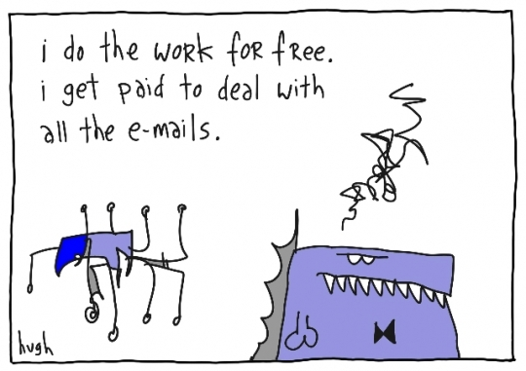

A recent study by American academics, published in the Wall Street Journal, reported that the average office worker gets distracted every three minutes and it might take as long as 23 minutes to get back on track. Their findings showed the barrage of emails between colleagues as a major cause, and not, as commonly believed, social media, blogs or news.

Picture the following situation. You arrive at work shortly after seven. The office is blissfully quiet and you look forward to a productive couple of hours before it starts buzzing with activity, questions and demands. You are determined to finalise that important progress report and come prepared to the nine thirty meeting with your boss. “Two hours is plenty of time, better get a coffee and quickly check my inbox,” you tell yourself.

What’s wrong with this scenario? The word ‘quickly’.

By nine you haven’t even opened the progress report and you already feel like another coffee. So, what have you been doing with your time?

Depending on the size of your project you could have been skimming through up to hundreds of emails, responding to some and archiving others, most of them irrelevant to your immediate priorities. And, you are not alone. Your colleagues will likely be doing the same at some stage during the day. In a project team of fifteen, that could add up to 30 hours. In one day.

Imagine that one of your developers reported a 30 hours delay in fixing a bug. As a project manager you would find that unacceptable. “That’s four days work,” you would no doubt protest. Yet, the same amount of time is often swallowed up on a daily basis by unnecessary email communication. This is scope creep, for which few will plan or budget, and most are unaware. Rather than inventing strategies to cope, we need to ask ourselves; Are large amounts of emails necessary? How can we use email communication more appropriately.

Email is not the right tool for sharing documents

Project documents, with their numerous changes and updates are often distributed by email. Recipients must archive emails and save attachments on their personal drives. Consider the many areas of project management plus other aspects and departments of the business and you already have two-dozen emails waiting in your inbox. This can be avoided by using a document management system, which also provides version control and a record of ownership and contributors.

Group emails are often irrelevant for most recipients

We all know the feeling of not wanting to miss out on vital information, and somehow we believe every aspect of a project is indirectly connected to what we are doing, including every email. This is to some extent true, but it steals focus and effort from your area of responsibility and delegation. Implementing sound documentation frameworks and communication management will make information more targeted and useful for the recipient. Appointing a Project Coordinator, whose sole responsibility it is to manage this, will in the long run cost less than lost productivity caused by team members reading emails not relevant to their task at hand.

Email does not replace verbal communication

It is ridiculous, and inefficient, to send emails to your colleagues across the room. Email was originally intended to make remote communication easier. It is quicker to get up from your desk, walk the short distance and ask your question or deliver a short message, than sending an email and in turn wait for their response. Also, email is not a suitable medium for urgent communication. When it is finally received and interpreted it might be too late for its intended purpose, and create misunderstandings or confusion. Short stand-up meetings are far more effective for keeping the project team up-to-date, and unforeseen, urgent matters should always be communicated face-to-face or by phone.

We need to rethink our dependence on email. According to the Wall Street Journal article some companies have started to allocate time when employees are not required to read or respond to emails. Ask yourself “what’s the worst thing that can happen if I ignore my inbox?” After all, fire, evacuation and other emergencies are not communicated by email.

